Capstone project - Final report

**Estimating Rates of Airbnb rentals based on the type and concentration of venues by using Clustering**

An

IBM - Data Science Specialization Course

By:

Prateeksha Hemraj

|  |  |
| --- | --- |
| **TABLE OF CONTENT** | |
| **Topic** | **Pg.** |
| **Introduction** | **2** |
| **Data Description** | **3** |
| **Methodology** | **4** |
| **Result** | **8** |
| **Discussion** | **12** |
| **Conclusion** | **13** |

**Introduction:**

Our Project is an attempt to learn by practically applying our theoretical understanding different aspects of analytics and data science. It is a part of our IBM Professional Data Science Specialization. We are expected to come up with a situation where we can resolve our problem by using Foursquare location data.

Our project aims at finding the Estimating the rental rates of Airbnb spaces based on location and facilities/services around the area. We refrained our study to Canada due to difficulty in finding relevant data.

With the coming up lodging industry, Airbnb came up with a revolutionary concept by providing us the facility of a home away from home. Now the question arises how people determine the rate of their space. It can depend on various factors like a availability of eating joints, visiting areas like parks, sites, museums or access to public transport etc.

So, can the surrounding venues affect the price of a house? If so, what types of venues have the most affect, both positively and negatively?

People who could benefit from this report could be:

* Tourists exploring different places.
* People traveling for business purposes.
* Airbnb Corp who can estimate their profit margins.
* People connected with Airbnb to rent out their free space. People getting connected with Airbnb are generally do not belong to the lodging industry and come from different walks of life. They see Airbnb as an additional source of income and not as a fulltime source of employment. They generally lack business understanding and face difficulty in estimating the rate they should offer for their space. This project will help them understand at what rate they can rent their space to benefit the customers and not suffer from losses either.

**Data description:**

Our study is based on Toronto city due to limitation of available data. Our parameters are restricted to nearby venues. We have not considered the size of the space due to limited resources. Among all options, 2-bedroom condos are considered the most popular choices. Therefore we are focusing on these spaces. We used Python language to perform data analytics

The radius of each cluster was limited to 500 meters. The variables were also limited to 100 venues per cluster

Due to the shear size of area, we are considering 5 clusters.

Following packages were installed for the analytics:

* Urlopen from Library urllib
* Beautiful soap from bs4
* pandas
* os
* requests
* Json_normalize
* Json
* Numpy
* Nominatim from geopy-geocoders
* Foliun
* Matplotlib.cm
* Matplotlib.colors
* Kmeans from sklearn.cluster

**Methodology:**

We found the geographic data of the locality, both their center coordinates and their border.

Data cleaning is a vital part of data analytics. Inaccurate data leads to inaccurate observations. Missing values were dealt with due care.

We extracted the Zip codes of each locality for more accurate.

We connected the zip codes with the latitudes and longitudes.

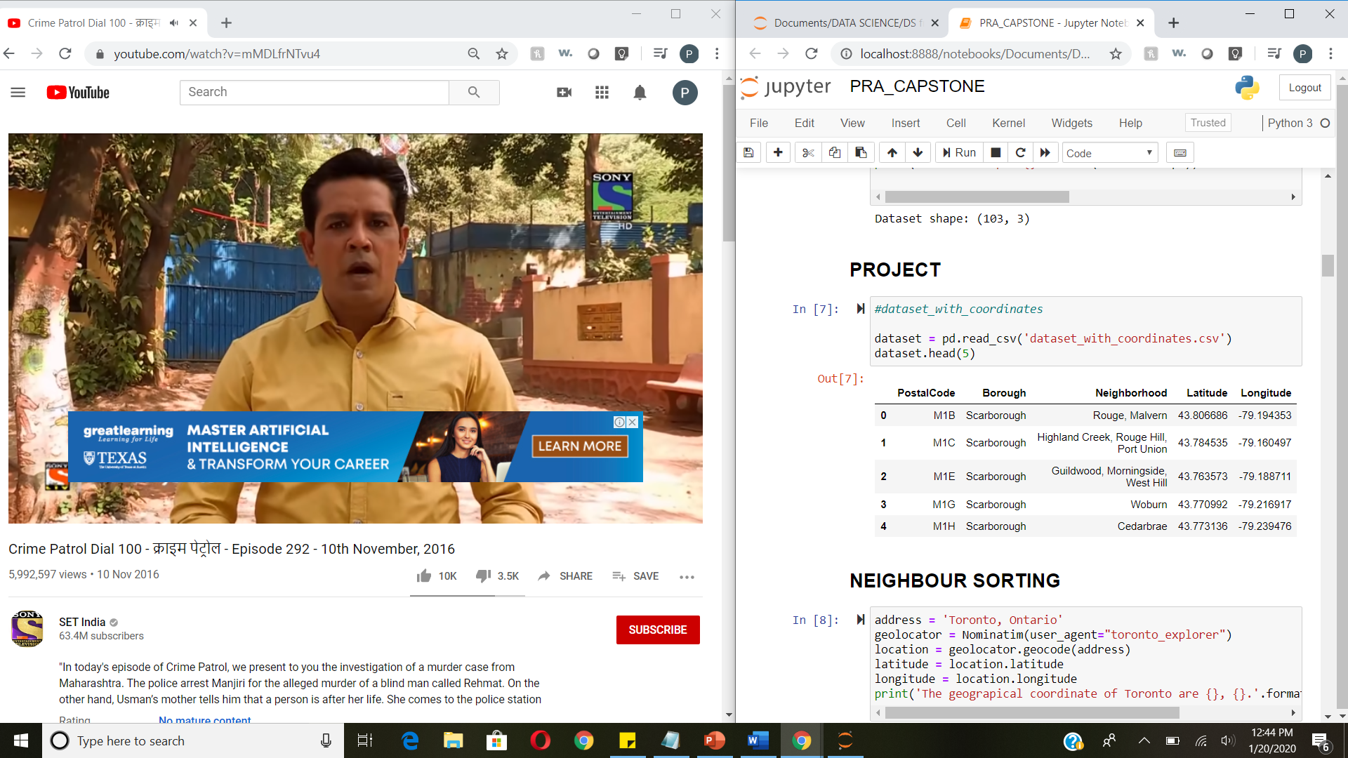

We also used Foursquare API to identify the surroundings based on the pre-defined radius (500meters in this case).

We then defined the center of the map. We later iterated through each row in the dataset plot plotted it in the map.

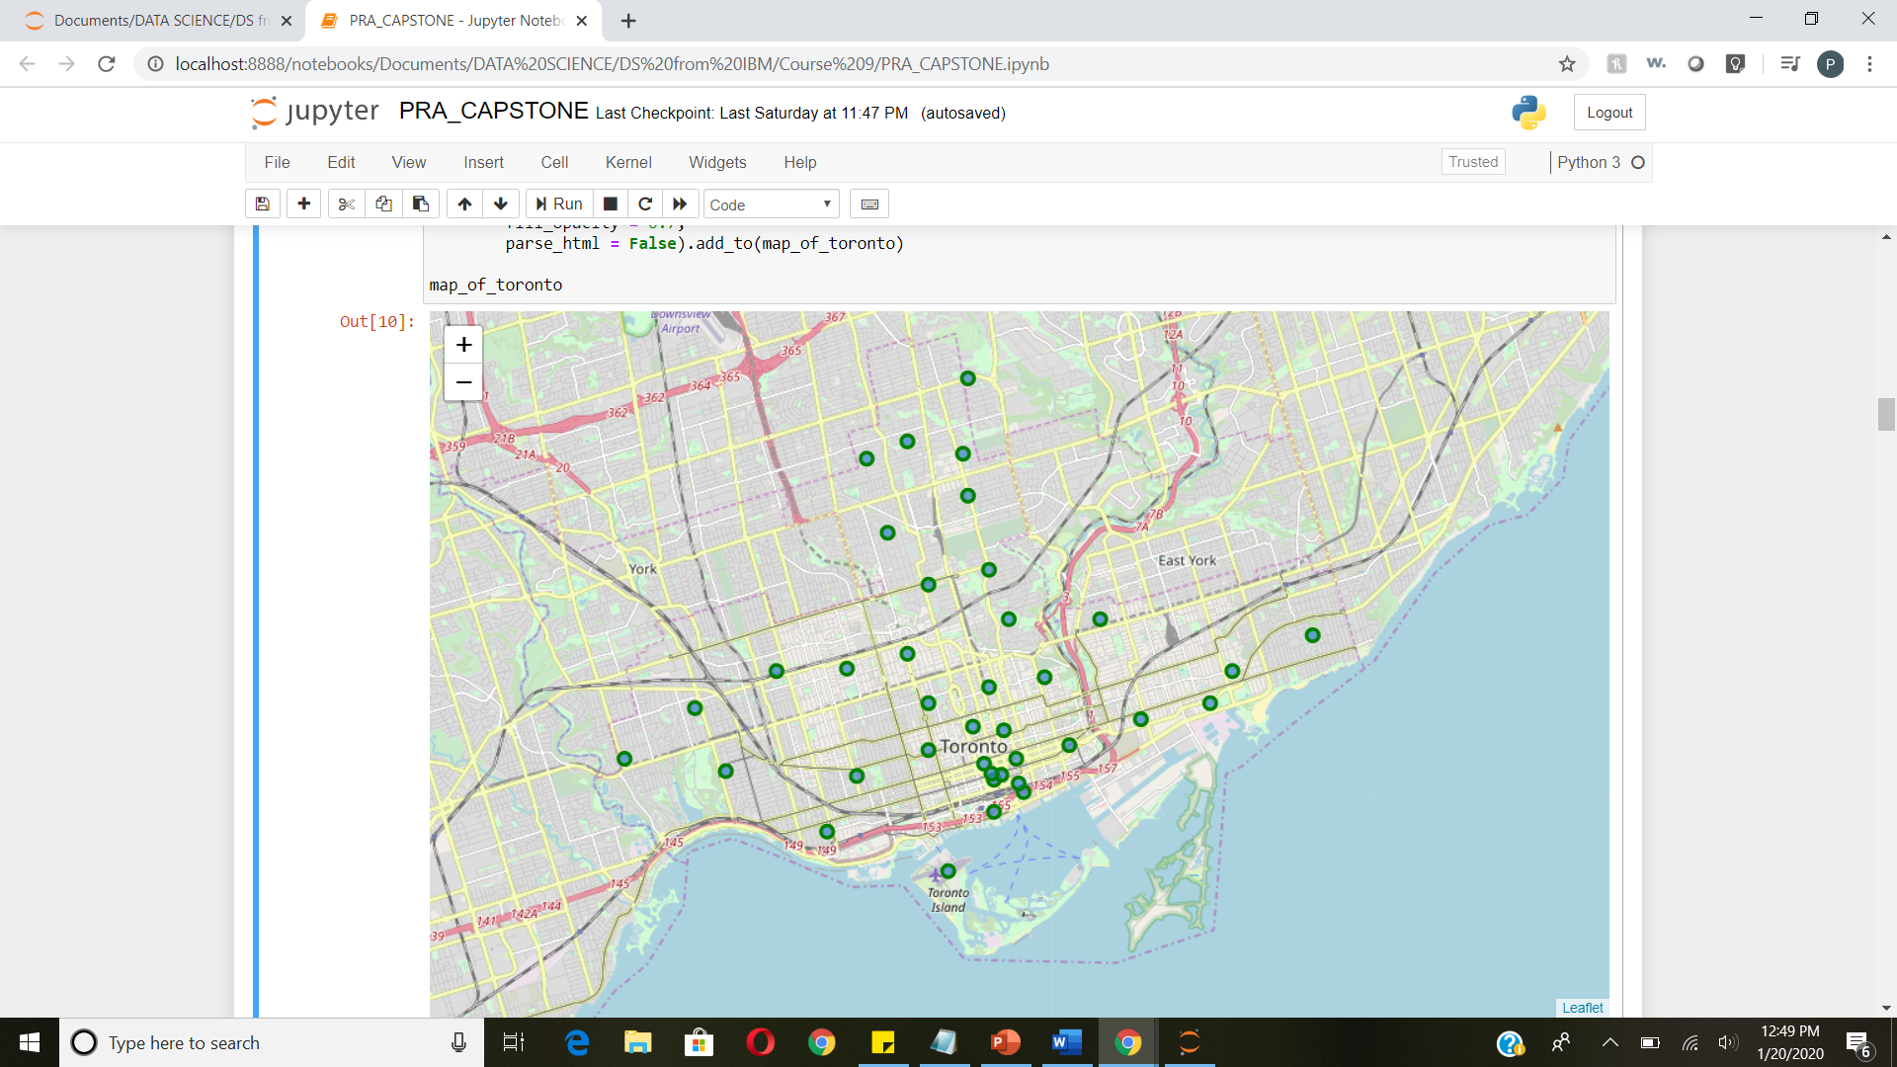

We calculated the occurrence of each venue type in a neighborhood. Later we applied one hot encoding to turn each venue type into a column with their occurrence as the value.

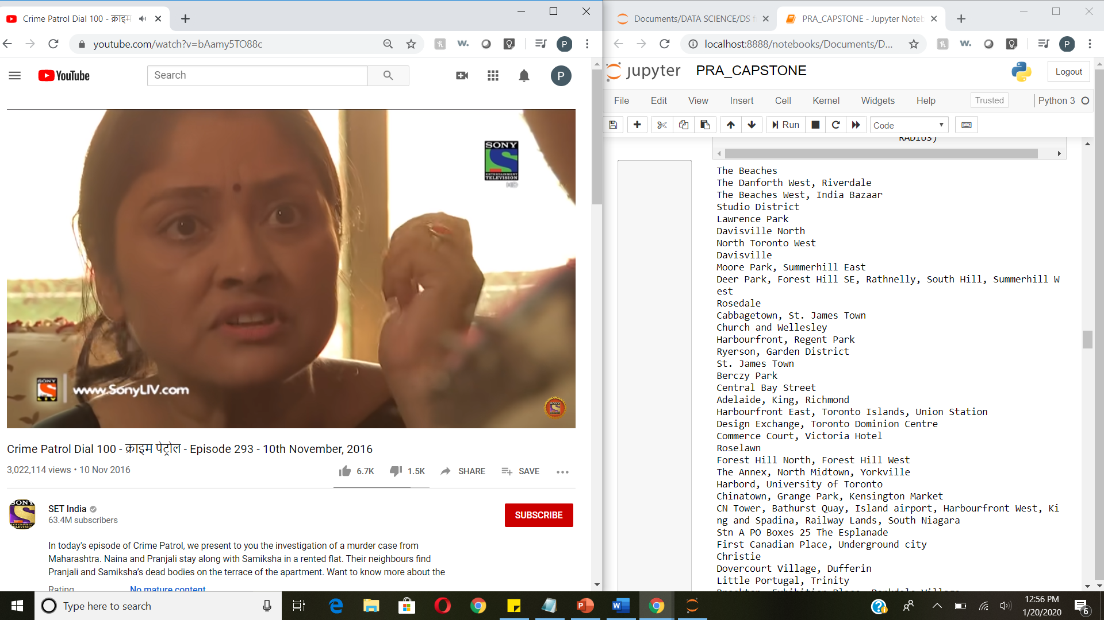­

Standardize the average price by removing the mean and scaling to unit variance.

The result dataset is a 2 dimensions data frame:

1. Each row represents each locality.
2. Each column, except the last one, is the occurrence of a venue type. The last column will be the standardized average price.

We also Plotted top 5 common venues in each locality.

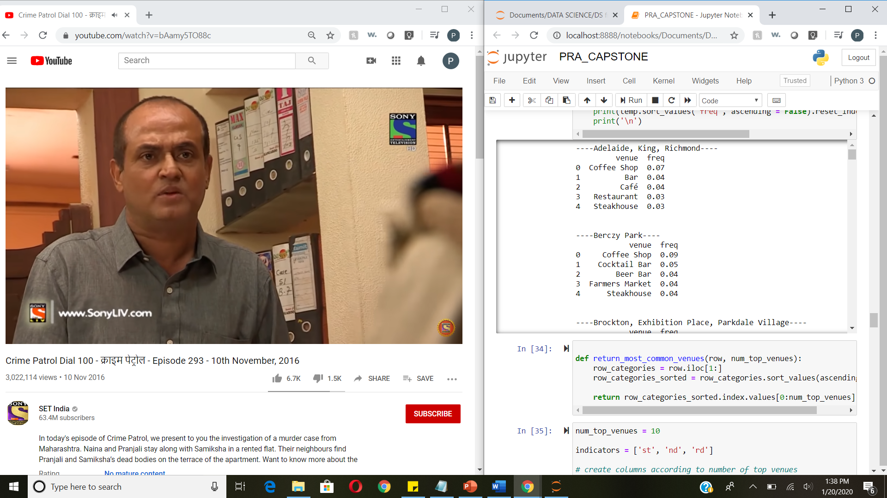

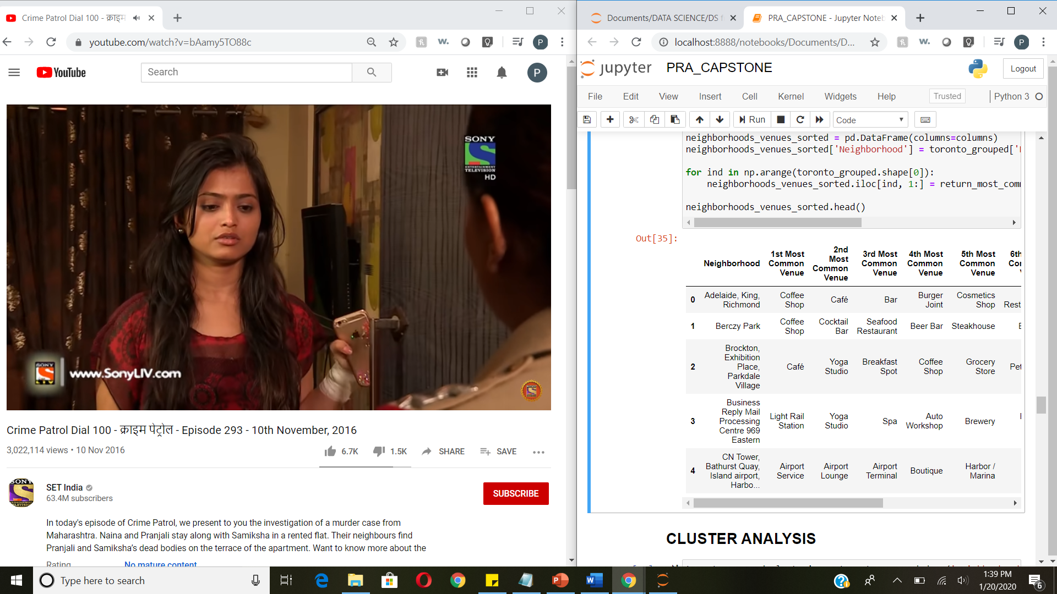

We later formed 5 clusters:

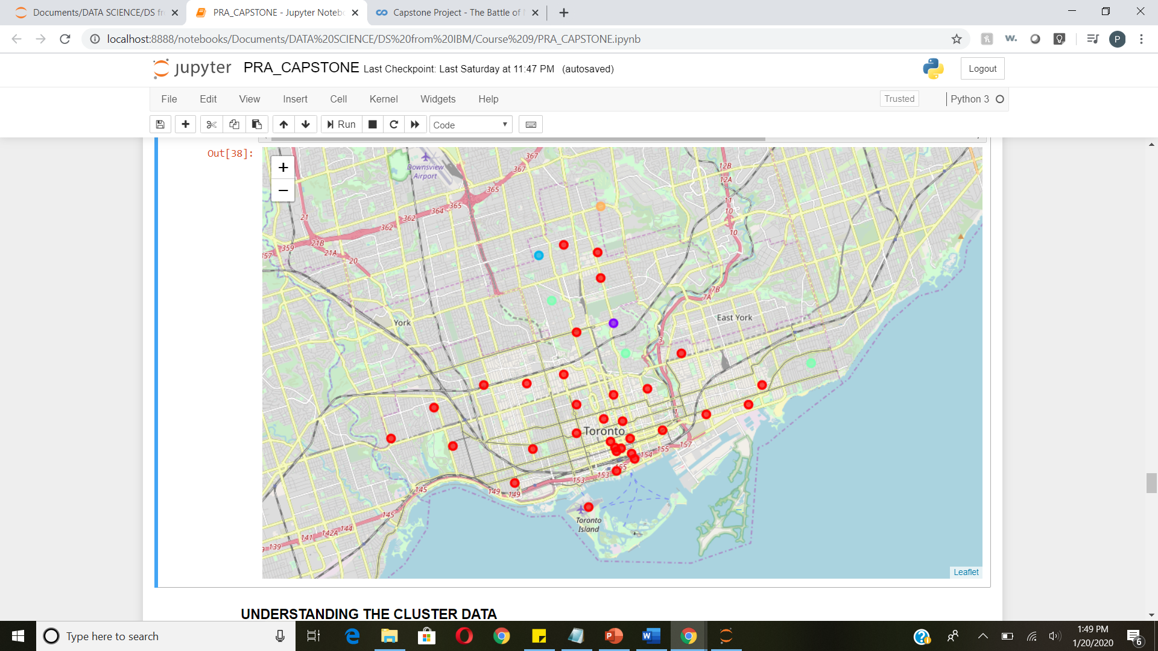

Notice the rates downtown are much higher. It a common trend for rental spaces gets expensive as we move towards the main downtown due to availability and concentration of venues. The rates reduce as we move upwards

**RESULT:**

Following are the details of each cluster. The tables are self- explanatory. It includes:

* Number of venues
* Frequency of all the venues

Second tables for each cluster includes:

* Location names
* Cluster codes
* List of most common venues in decreasing order of preferences.

CLUSTER 1:

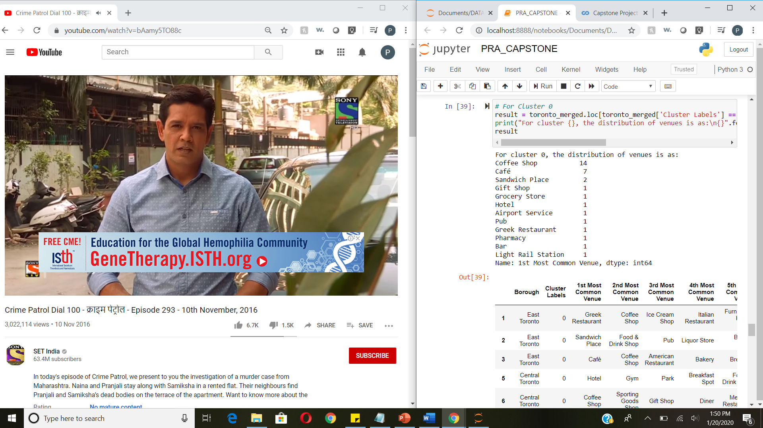

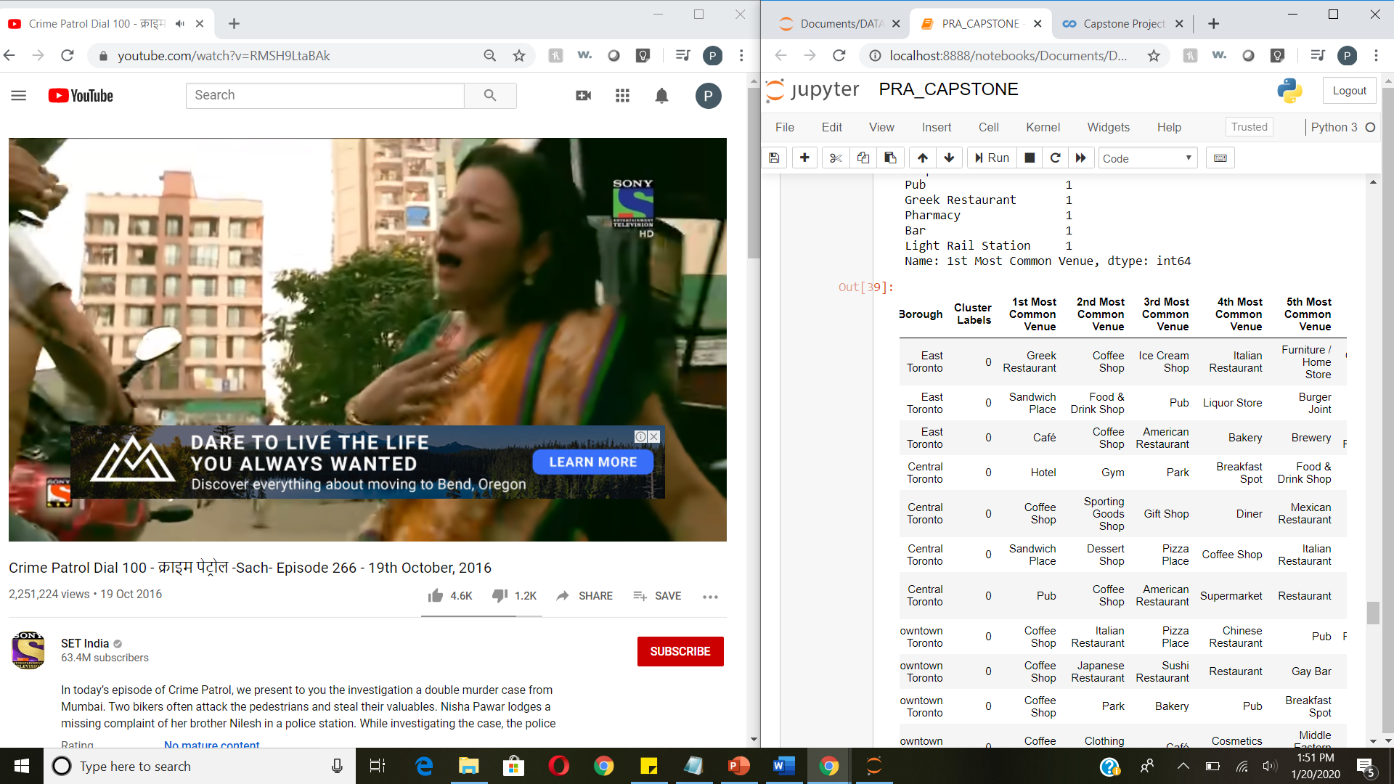

CLUSTER 2:

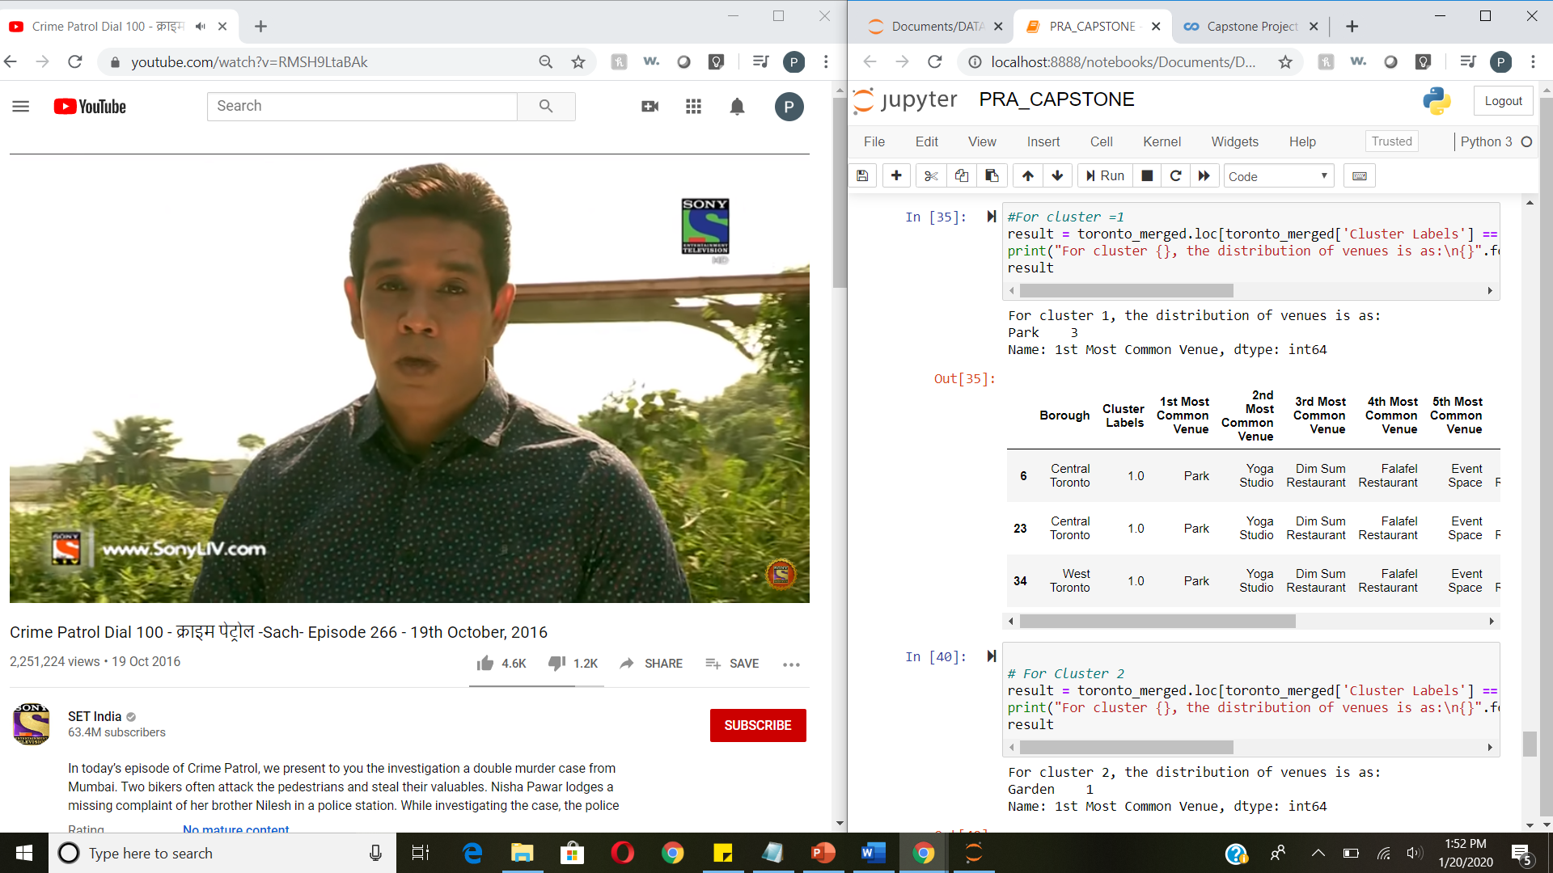

CLUSTER 3:

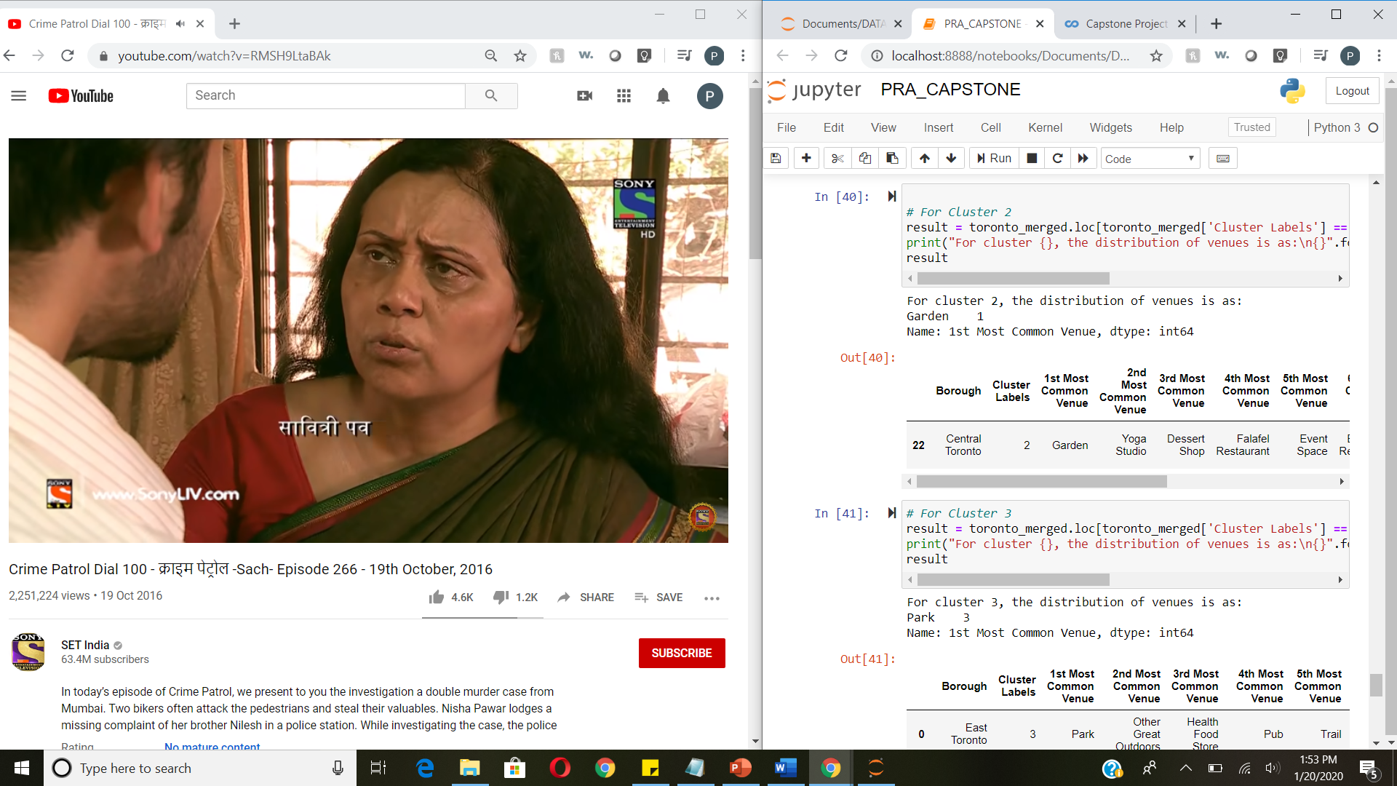

CLUSTER 4:

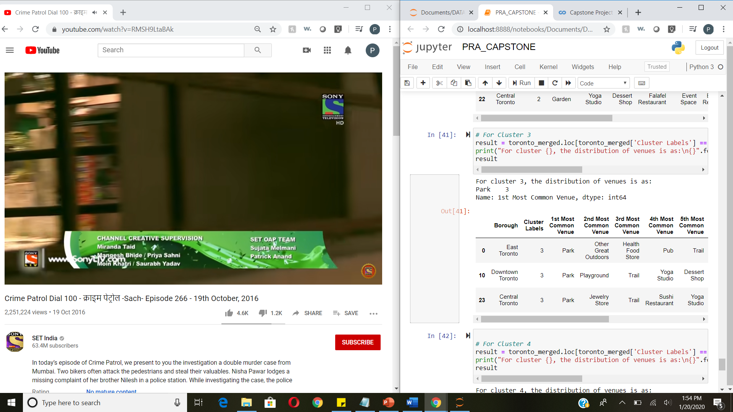

CLUSTER 5:

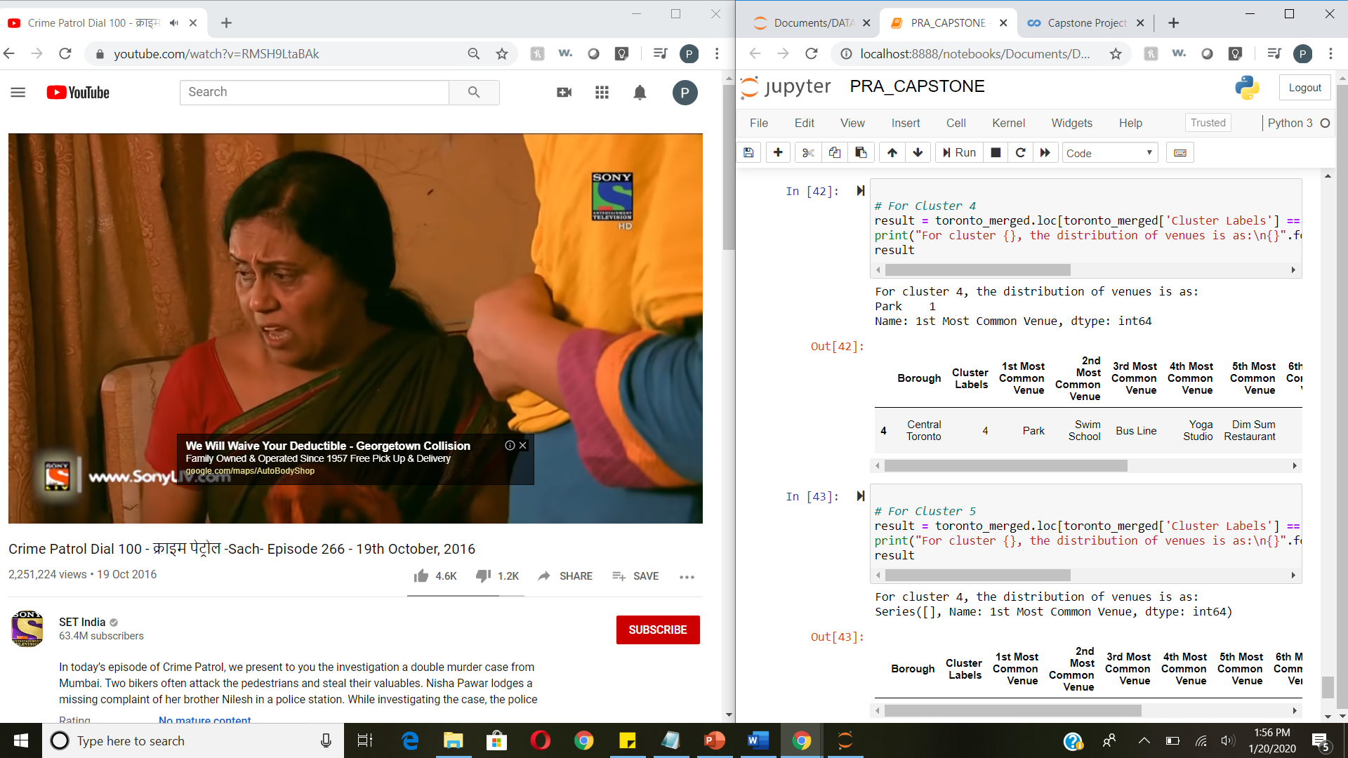

Even though the scores seem to be improved after applying a more sophisticate method, the model is still not suitable for the dataset. Thus, it can’t be used to precisely predict a space’s average rental.

Explanations for the poor model can be:

* The real estate price is hard to predict. Rental spaces’ rates are highly depended on the real estate prices.
* The data is limited (small sample size, missing deciding factors).

But again, on the bright side, the insight, gotten from observing the analysis results, seems consistent and logical. It might give the new joinees of Airbnb to determine the rates they could charge based on the location of the space and the number and type of venues surrounding it.

**Discussion:**

The real challenge is constructing the dataset:

* Usually the needed data isn’t publicly available.
* When combining data from multiple sources, inconsistent can happen. And lots of efforts are required to check, research and change the data before merge.
* For data obtained through API calls, different results are returned with different set of parameters and different point of time. Multiple trial and error runs are required to get the optimal result.
* Even after the dataset has been constructed, lots of research and analysis are required to decide if the data should be kept as is or be transform by normalization or standardization. It can be considered the most important process in the whole data science pipeline. Which can affect the most on the result.
* On the other hand, choosing the suitable technique to construct the model is also a worthwhile process. As this report shows that, by applying a different method, the result can be improved.

**Conclusion:**

It’s unfortunately that the analysis couldn’t produce a precise model or showing any strong coefficient correlation for any venue type. But we can still get some meaningful and logical insights from the result.

Doing this project helps practicing every topic in the specialization, and thus, equipping learners with Data Science methodology and tools using Python libraries. Also doing a real project certainly helps one learns so much more outside the curriculum, as well as realizes what more to research into after completing the program. And as this report shows, there are surely a lot of things to dig into.

Some notes on the analysis result:

* This project is done by a web developer who only started self-studying Data Science for 4 months. So please take it with a grain of salt.
* The coefficients only show correlation, not causation

Toward the person that went through this project, many thanks for the time and patient.